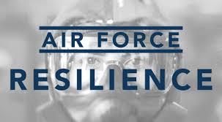

How connected do you feel to your fellow Airmen?
Very Disconnected | Somewhat Disconnected | Neutral | Somewhat Connected | Very Connected

How can we increase connection within Squadrons?

What level of trust and confidence do you have in your unit leadership?
Little Trust and Confidence | Some Trust and Confidence | Moderate Trust and Confidence | Great or High Trust and Confidence | Full Trust and Confidence

How can we build higher trust and confidence?

Which tools and resources are helpful?

Which tools and resources could be improved?

What can be done to break down barriers to seeking help?

Where do you find information to get help?

How can we better provide information on how to get help?

What do you think of the small group discussion format? What is the overall tone and mood of your group discussion?

What do you recommend for future themes and/or activities?

Other comments/suggestions (optional)

www.resilience.af.mil

